Week 1 and 2 (LINUX and ROS learning)

LINUX

pwd = print working directory
mkdir = make directory
shift+ctrl+T = open a new tab in the terminal
shift + PrtSc = snip image in ubuntu
cd = goes to home directory
rmdir = remove a folder
rm -r [name of the directory] = remove entire directory

https://lucidar.me/en/dev-c-cpp/how-to-install-qt-creator-on-ubuntu-16-04/ = this is used to install qt creator

#!/usr/bin/env python = have to always prepend this in front of the python script
chmod +x location_monitor_node.py = make a python file executeable on linux

ROS

rosversion -d = this is to show the ros version
rospack find roscpp = find the filepath of the "roscpp" packages
roscd roscpp = move to the "roscpp" directory
rosls roscpp = list out the files in the "roscpp" packages' directory

steps to create a workspace
1) mkdir -p ~/catkin_ws/src = make a directory with catkin_ws as the parent folder and src as the sub folder
2) cd ~/catkin_ws/src
2) catkin_init_workspace = create a workspace (add in the “CMakeLists.txt” file)
3) cd ~/catkin_ws = go to the workspace
catkin_make = build the project in the workspace

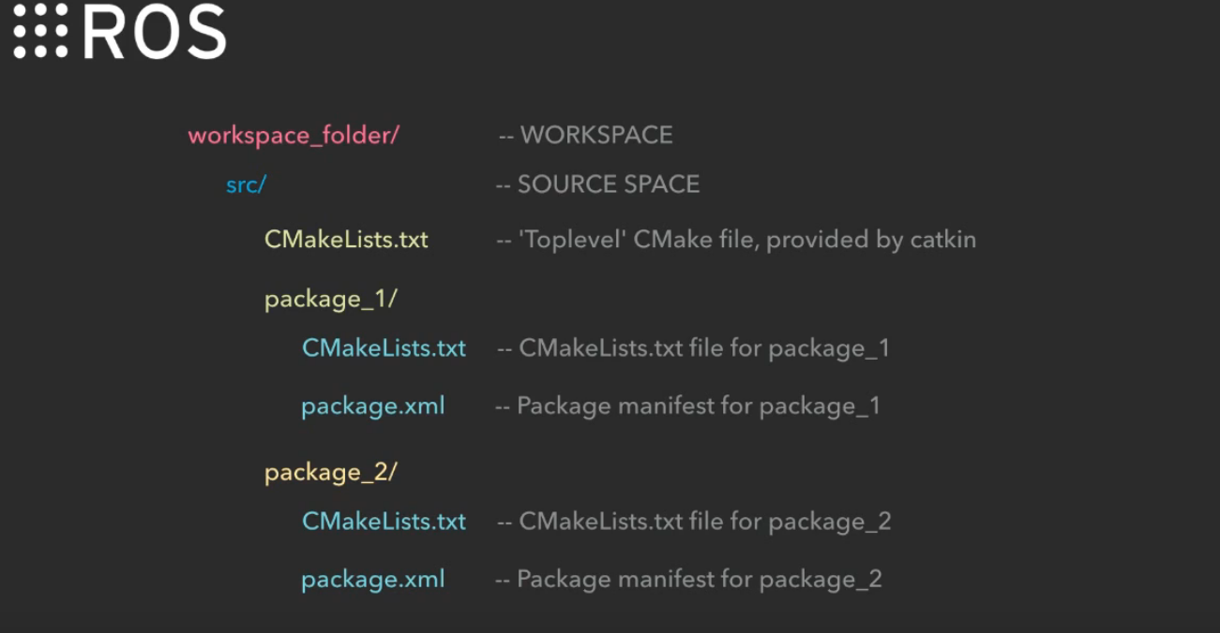
this is the file structure for ROS workspace

WORKSPACE = catkin_ws
SOURCE SPACE = src

steps to create package
1) cd ~/catkin_ws/src
2) catkin_create_pkg beginner_tutorials std_msgs rospy roscpp (these 3 are the dependencies on which the package depends) = creating a package called “beginner_tutorials” with “CMakeLists.txt” and “package.xml” added in it
3) cd ~/catkin_ws = go to the workspace
catkin_make = build the project in the workspace and add in the changes

roscore = running the master
rosrun turtlesim turtlesim_node = running of node
rosrun turtlesim turtle_teleop_key = running of another node

rosnode list = shows all the nodes that are running
rosnode -h = rosnode help. this will show the commands for printing information about the nodes
rostopic -h = rostopic help. this will show the commands for printing information about the topics
rostopic list = shows all the topics that are running

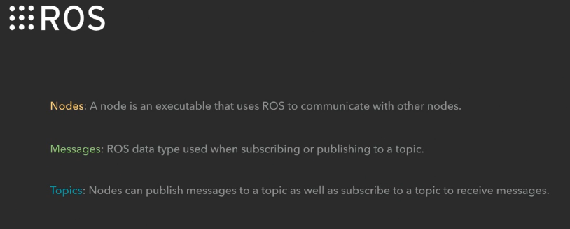
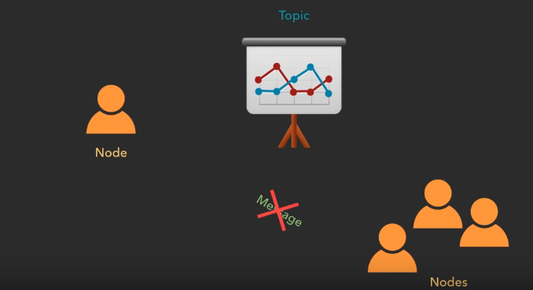
this showcases the definition and relationships of nodes, topics and messages in ROS

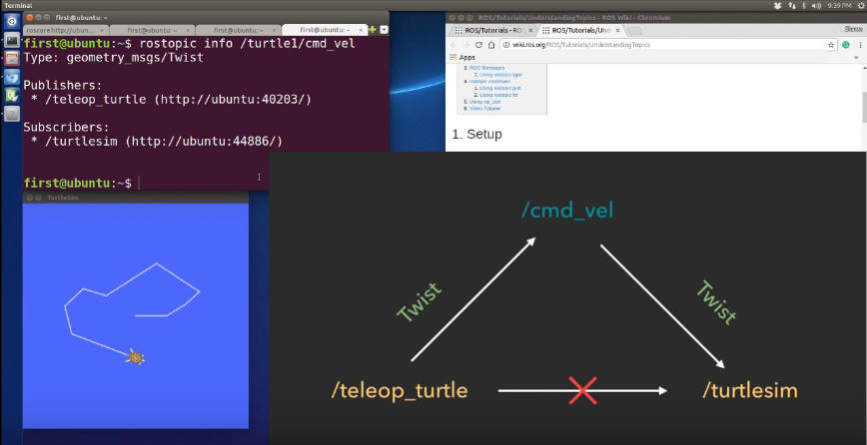
rostopic info /turtle1/cmd_vel = this command will show the message, publisher and subscriber
for the “cmd_vel” topic

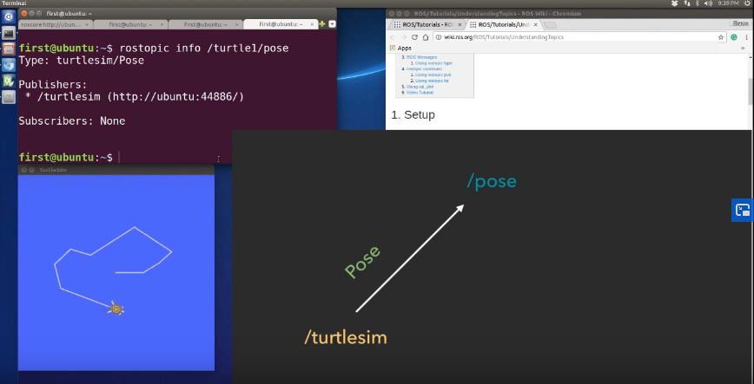
rostopic info/turtle1/pose = this command will show the message, publisher and subscriber for the
“pose” topic

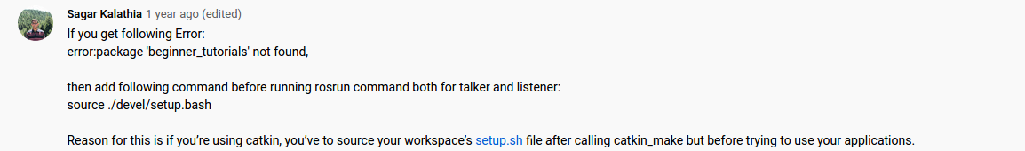
source ./devel/setup.bash (this will only work after you just catkin_make the workspace)

OR

source ~/{name of the workspace}/devel/setup.bash
e.g. source ~/practise_ws/devel/setup.bash

rosrun will only work after source ~/{name of the workspace}/devel/setup.bash

rostopic type /odom = this will show the type of a topic

Useful youtube links:

https://www.youtube.com/c/JustinHuang101/videos

https://www.youtube.com/channel/UCQLEPbkEmwz4mABAV-kzQTQ/videos

Week 3 and 4 (face recognition related learning)

face_recognition library

https://pypi.org/project/face-recognition/

example of face_recognition

https://github.com/jacques-saraydaryan/ros_face_recognition

tutorial on facial_recognition library:
images
https://www.youtube.com/watch?v=535acCxjHCI

video
https://www.youtube.com/watch?v=PdkPI92KSIs

cvbridge – used to convert python images to ros images (and vice versa):
http://wiki.ros.org/cv_bridge/Tutorials/ConvertingBetweenROSImagesAndOpenCVImagesPython

cvbridge’s documentation
http://docs.ros.org/hydro/api/cv_bridge/html/python/index.html

Week 5 and 6 (Integration on ROS and pyrobot + Enhancement)

ROS publisher and subscriber

import rospy
rospy.loginfo(‘closest: {}’.format(closest_name)) = this is the format for printing stuff in ros

Week 7

id: respeaker
password: respeaker

ssh for respeaker
sudo ssh respeaker@192.168.43.61 (this only works when the respeaker and pc are connected to same internet) = ssh for xiaomi phone
sudo ssh respeaker@192.168.1.136 = ssh at home
sudo nmtui = go into the internet connection settings

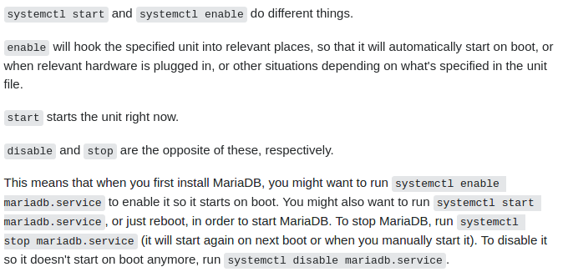
systemctl start and systemctl enable do different things.
enable will hook the specified unit into relevant places, so that it will automatically start on boot, or when relevant hardware is plugged in, or other situations depending on what's specified in the unit file.
start starts the unit right now.
disable and stop are the opposite of these, respectively.
This means that when you first install MariaDB, you might want to run systemctl enable mariadb.service to enable it so it starts on boot. You might also want to run systemctl start mariadb.service, or just reboot, in order to start MariaDB. To stop MariaDB, run systemctl stop mariadb.service (it will start again on next boot or when you manually start it). To disable it so it doesn't start on boot anymore, run systemctl disable mariadb.service.

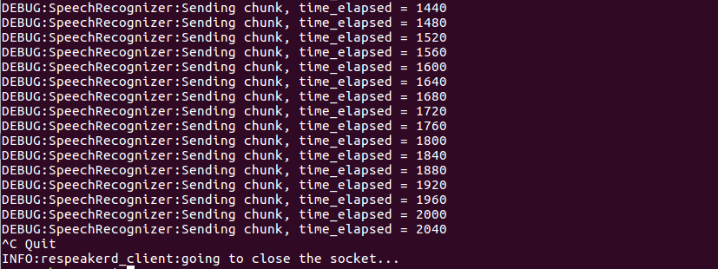

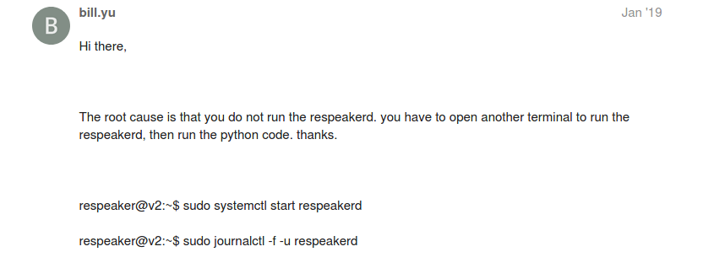
sudo systemctl start respeakerd
sudo journalctl -f -u respeakerd
pulseaudio --kill

arecord -D plughw:1,0 -f cd test.wav (arecord -D plughw:[card],[device] -f cd test.wav) = record sound

aplay -D plughw:1,0 -f cd test.wav (aplay -D plughw:[card],[device] -f cd test.wav) = play sound

run pycharm for debugging:

1) cd pycharm-community-2020.2.3/bin/

2) sh pycharm.sh

3) file > settings > project > python intepreter:

/home/michaellimyuguang/pyenv_pyrobot_python2/bin/python

/opt/ros/kinetic/lib/python2.7/dist-packages

this is the place to find msg

pocketsphinx

https://cmusphinx.github.io/wiki/tutoriallm/

https://www.youtube.com/watch?v=VLhj_WYxo7g&list=WL&index=9&t=235s

https://www.youtube.com/watch?v=pl1w_p8dXuY&t=343s

https://pypi.org/project/pocketsphinx/

these 3 files are required to make pocketsphinx work
en-US
en-us.lm.bin = probability of all the keyword in binary format
cmudict-en-us.dict = pronunciation of the keyword

convert en-us.lm to en.us.lm.bin using this code

sphinx_lm_convert -i en-us.lm -o en.us.lm.bin

set default audio device in ubuntu
https://rastating.github.io/setting-default-audio-device-in-ubuntu-18-04/

output
pactl list short sinks
pactl set-default-sink ‘....’

pactl set-default-sink 'alsa_output.usb-SEEED_ReSpeaker_4_Mic_Array__UAC1.0_-00.analog-stereo'

input
pactl list short sources
pactl set-default-source ‘....’

pactl set-default-source 'alsa_input.usb-SEEED_ReSpeaker_4_Mic_Array__UAC1.0_-00.multichannel-input'

pactl set-default-source 'alsa_input.usb-SEEED_ReSpeaker_4_Mic_Array__UAC1.0_-00.analog-mono'

web service to create language model
www.speech.cs.cmu.edu/tools/lmtool-new.html

srilm language model (create my own language model)
/usr/share/srilm/bin/i686-m64/ngram-count -interpolate -text corpus.txt -lm my_lm.lm
/usr/share/srilm/bin/i686-m64/ngram -lm my_lm.lm -prune 1e-8 -write-lm my_pruned_lm.lm

this will help to reduce the roslaunch syntax

mkdir -p ~/catkin_ws/src && ~/catkin_ws/src
git clone https://github.com/furushchev/respeaker_ros.git
cd ~/catkin_ws
source /opt/ros/kinetic/setup.bash
rosdep install --from-paths src -i -r -n -y
catkin config --init
catkin build respeaker_ros
source ~/catkin_ws/devel/setup.bash

